SAPAA Alternative Report
Instructions: Use the online reporting form for most site visits: Site Inspection Form. Use this document if you prepare annual reports or have other reporting needs. Send the completed form to President@sapaastewards.com. It will be forwarded to the responsible ministry(ies) as part of the annual reporting process. Do not use this form to report illegal activities or significant disturbances.
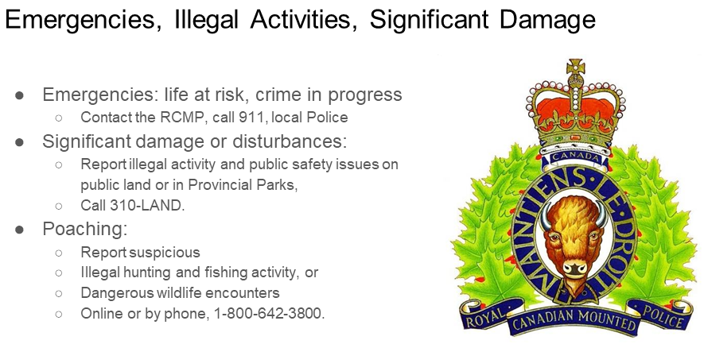
This form is available in three formats: Microsoft Word, Google Document, or as a PDF. SAPAA accepts the first two formats and the pdf format is provided only as a courtesy.

A Note on the Questions
The questions are from the now defunct Government of Alberta’s site inspection form. Where a question matches one from the current SAPAA site inspection form, a cross reference is provided to the question (Q##) and [section]. (NA) is used if there is no equivalent question.

General Information [Who Are You]
Steward's Name (Individual or Group) [Name] (Q12)
Steward's [Email] (Q11)
Inspection [Date] (Q21)
Site [Name] (Q22)
Optional Inspection [Number] (NA)
Volunteer hours since last report [Number] (NA)
Phone [Number] (Q14)

Disturbance: Vegetation / Animals

Change in Site Condition [Yes/No] (NA)
Bark Stripping [Yes/No, NA] (Q65)
Collecting / Trapping [Yes/No, NA] (Q65)
Poaching [Yes/No, NA] (Q65)
Tree Cutting [Yes/No, NA] (Q65)
Fire [Yes/No, NA] (Q65)

Other Vegetation or Animal Disturbance [Comment] (Q65)

A. Disturbances: Soil Removal

Sand [Yes/No, NA] (Q62)
Peat [Yes/No, NA] (Q62)
Gravel [Yes/No, NA] (Q62)
Other Soil Disturbance [Comment] (Q62)
A. Disturbance: Vandalism
Garbage [Yes/No, NA] (Q65)
Cut Fences [Yes/No, NA] (Q65)
Signs [Yes/No, NA] (Q65)

Other Vandalism Disturbance [Comment] (Q67)

A. Disturbances: New Trails / Cleared Lines

All-Terrain Vehicles [Yes/No, NA] (Q63)
Hiking / Equestrian [Yes/No, NA] (Q64)
Fences [Yes/No, NA] (Q55)
Powerlines [Yes/No, NA] (Q66)
4 Wheel Driving [Yes/No, NA] (Q64)
Cutlines / Seismic [Yes/No, NA] (Q66)
Pipelines / Wellsites [Yes/No, NA] (Q66)

Other New Trails or Cleared Lines Disturbance [Comment] (Q67)

B. Recreation

ATVing [Yes/No, NA] (Q64)
4-Wheel Vehicles [Yes/No, NA] (Q64)
Berry Picking [Yes/No, NA] (Q61)
Hiking [Yes/No, NA] (Q64)
Bird Watching [Yes/No, NA] (Q64)
Trail Riding (horse) [Yes/No, NA] (Q64)
Fishing [Yes/No, NA] (Q64)
Camping [Yes/No, NA] (Q64)
Picnicking [Yes/No, NA] (Q64)
X Country Skiing [Yes/No, NA] (Q64)
Snowmobiling [Yes/No, NA] (Q64)
Hunting [Yes/No, NA] (Q64)

Other Recreation [Comment] (Q67)

B. Uses: Other

Cattle Grazing [Yes/No, NA] (Q61)
Horse Grazing [Yes/No, NA] (Q61)
Other Uses [Yes/No, NA] (Q 61)

Comments on Uses [Comment] (Q 61)

C. Biological Notes (optional)
List of plant/animal species, or other information [Comment] (Q51/52)

D. Action Recommended: Reclamation

Fencing [Yes/No, NA] (Q74)
Re-vegetation [Yes/No, NA] (Q74)
Cleanup [Yes/No, NA] (Q74)
None [Yes/No, NA] (Q74)

D. Action Recommended: Materials & Supplies

Signs [Yes/No, NA] (Q74)
Fence Wire [Yes/No, NA] (Q74)
Inspection Report [Yes/No, NA] (Q72)
Posts [Yes/No, NA] (Q74)

Other Actions Recommended [Comment] (Q74)

E. Projects Completed Since Last Inspection

Signs Installed [Yes/No, NA] (Q72)
Cleanup [Yes/No, NA] (Q72)
Weed Control [Yes/No, NA] (Q72)
Fencing [Yes/No, NA] (Q72)

Other Projects [Comment] (Q72)

F. Summary
Change in general site condition since last inspection [No Change, Improved, Deteriorated] (NA)
Summary Comments [Comment] (Q82)

G. Additional Information & Photos
Will you be sending additional information? [Yes/No, NA] (Q81)

